


The University of Jordan
Faculty of Engineering and Technology
Chemical Engineering Department
Chemical Engineering Laboratory2
Experiment (9)
Title Of The Experiment:
BALL MILL
Done by:
Name
Mariam Suleiman
Sajeda Mahmoud
Esraa Abu Saefan
Lina Hudaib

Instructor: Dr.Motasem Saidan
Report Type: short Report
Date Of Performance: 15/12/2021
Date Of Submitting: 22 /12 /2021

Abstract:

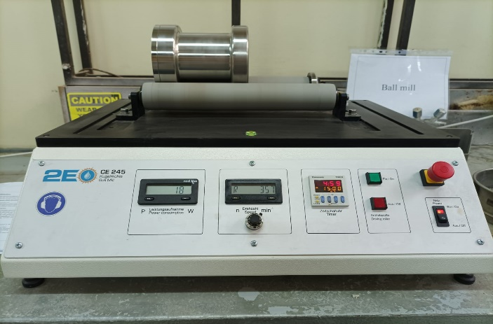
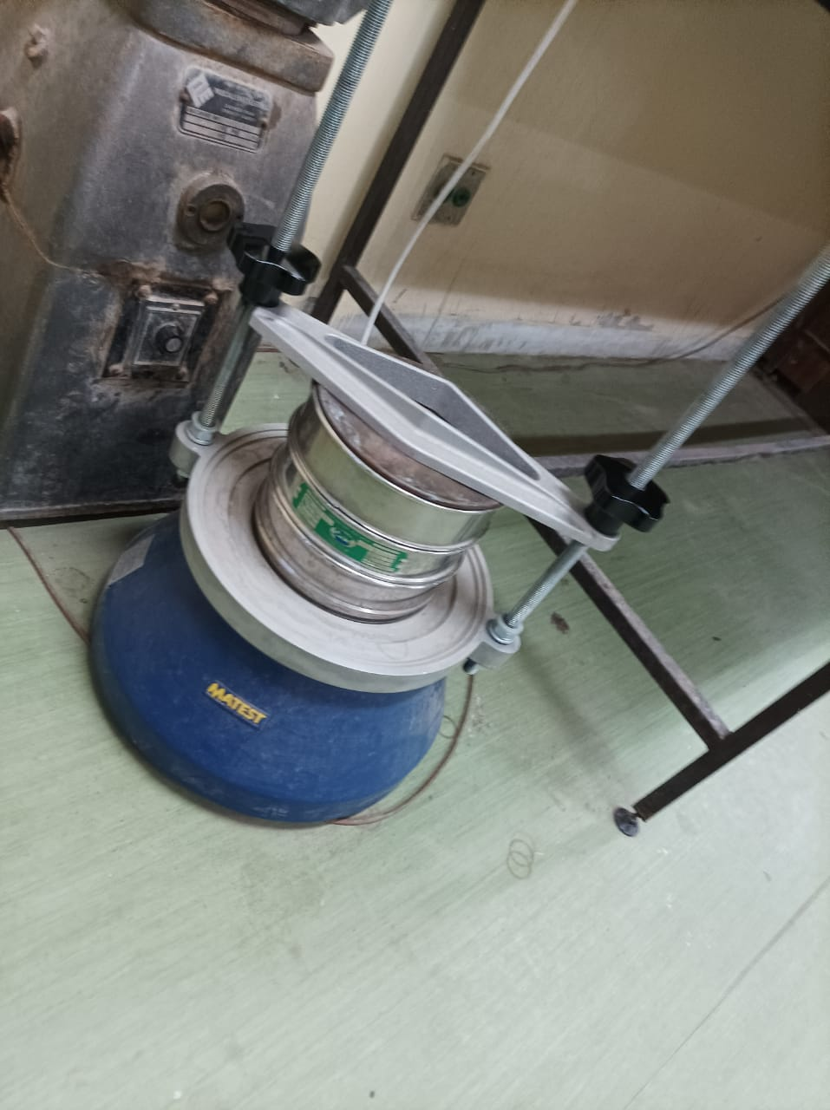
A ball mill is a type of grinder used to grind the given material to a smaller size using a ball mill and to obtain the size distribution of the final mixture by sieving .The size reduction leads to an increase in surface area per unit volume that enhances the rate of the reaction by allowing more sites for the reaction to take place.
The ball mill contains a hollow cylindrical shell that rotates about its axis. This cylinder is filled with balls that are made of stainless steel to the material contained in it . Ball mills are usually used for grinding the materials into an very fine form.
Figure 2:Ball mill layout
Figure 1:sevies

Contents
Abstract: 2
Result : 4
7
Discussion : 7
Conclusion: 8
References: 8
• McCab,W.L.,and Smith,J.C.,Unit Operation of Chemical Engingeering,McGraw-Hill,Inc,3rd ed.,(1976). 8
Appendices: 8

Figure 1: inital pticle size 850 4
Figure 2; initial particle size 500 5
Figure 3:power aganist partice size 5

Result :

Table 1 : data
 | Sample #1 | Sample #2
feed particle size | 850 | 500
weight of sample | 54.55 | 54.58
time | 15.00 | 15.00
rotation speed | 357.50 | 358.00
power consumpion | 18.00 | 17.00

Table 2 : sample 1
Sample #1
Diameter (mm) | Average diameter (mm) |  |  | Weight (g) | mass fraction % | cumulative weight |  | cum %
Column1 | Column2 | Column3 | Column4 | Column5 | Column6 | Column7 | Column8 | Column9
x>500 | 500 |  |  | 0.542 | 1.018720397 | 0.542 |  | 1.018720397
355<x<500 | 427.5 |  |  | 0.662 | 1.244267348 | 1.204 |  | 2.262987745
250<x<355 | 302.5 |  |  | 1.19 | 2.236673934 | 2.394 |  | 4.49966168
125<x<250 | 187.5 |  |  | 12.883 | 24.21434479 | 15.277 |  | 28.71400647
90<x<125 | 107.5 |  |  | 18.661 | 35.07443049 | 33.938 |  | 63.78843696
90>x | 45 |  |  | 19.266 | 36.21156304 | 53.204 |  | 100
53.204

100

Table 3: sample 2
Sample #2
Diameter (mm) | Average diameter (mm) | Column1 | Column2 | Weight (g) | mass fraction % | cumulative weight | Column3 | cum %
355<x<500 | 427.5 |  |  | 0.982 | 1.839123513 | 0.982 |  | 1.839123513
250<x<355 | 302.5 |  |  | 0.883 | 1.653712894 | 1.865 |  | 3.492836408
125<x<250 | 187.5 |  |  | 10.689 | 20.01872835 | 12.554 |  | 23.51156475
90<x<125 | 107.5 |  |  | 29.407 | 55.07444517 | 41.961 |  | 78.58600993
90>x | 45 |  |  | 11.434 | 21.41399007 | 53.395 |  | 100
 |  |  |  | 53.395 | 100

Figure 3: inital pticle size 850

Figure 4; initial particle size 500

 | feed particle size | Power
1 | 850 | 18
2 | 500 | 17

Figure 5:power against particle size

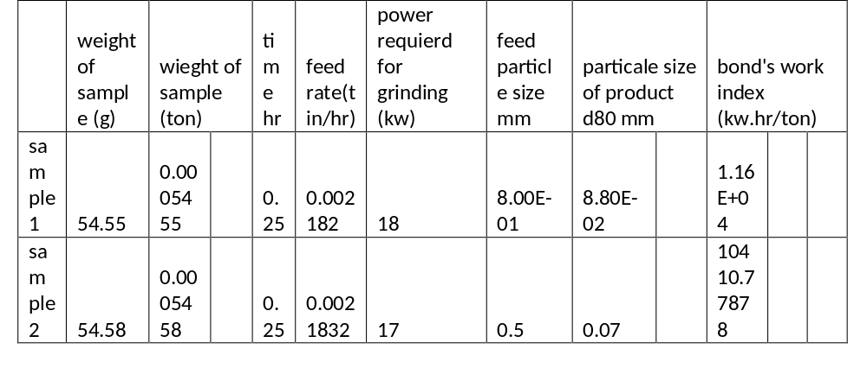
Table 4 powe and index

Discussion :

In this experiment, we will study the milling process of oil shale particles. All factors will be constant except for the initial particle size before the milling process, and we will study its effect on the amount of energy consumed to mill the particles Where we will set the speed of rotation and the number of balls inside the cylinder to remain constant .At first, we put particles of oil shale with a diameter of 850 micrometers inside the cylinder and put inside a large number of small metal balls of varying size so that the milling process is better because the driving force will be higher. Here the amount of energy consumed was 18 watts.
In the second sample we put particles with a diameter of 500 micrometers and here the amount of energy consumed was 17 watts We calculated the amount of energy consumed by this law:
$$\frac{p}{m}=0.3162 W_{i}\left(\frac{1}{\sqrt{L_{2}}}-\frac{1}{\sqrt{L_{1}}}\right)$$
We also note from the data that the larger the size of the initial particles, the greater the amount of energy consumed in the milling process.
After the milling process is completed, we will put the product in the sieves to calculate the size of the particles after the grinding process.
there will be slight errors in the readings because of the volatilization of some dust from the resulting material after milling and due to its adhesion to the walls of the cylinder and to the outer surface of the balls used in the milling process.

Conclusion:
- There are some variables affect crushing process such as: Initial material size, time & the Properties of material to be ground (hardness, brittleness, viscosity)
- We using a constant weghit of sample ,constant time and changing particle size.
- As shown in the figure the relation between power required and particle size directly proportional
- The accumulative weight percent of product descrees when screen opening increase.

References:

McCab,W.L.,and Smith,J.C.,Unit Operation of Chemical Engingeering,McGraw-Hill,Inc,3rd ed.,(1976).

Appendices:

Sample of calculation
Sample #1:
feed particle size:850 $μm$
weight of sample: 54.55 g
wieght of sample (ton) : 54.55/100000 = 0.00054.55ton
time : 15 min
time (h) : 0.25
rotation speed : 357 rpm
power :18 W
feed rate(tin/hr) = weight(ton) / t (h)
=0.0005455/0.25 = 0.002182

- from the Accumulative weight percent VS screen opening (micro meter) graph : $d_{80}=88 μm$

Bonds law:
$$\frac{p}{m}=0.3162 W_{i}\left(\frac{1}{\sqrt{L_{2}}}-\frac{1}{\sqrt{L_{1}}}\right)$$

bond's work index (kw.hr/ton) = ((18/0.002182)/0.3162)/((1/(8.80*10-3)1/2 )- (1/(8.50*10-3)1/2 )) = 1.16*10⁴ kw.hr/ton

